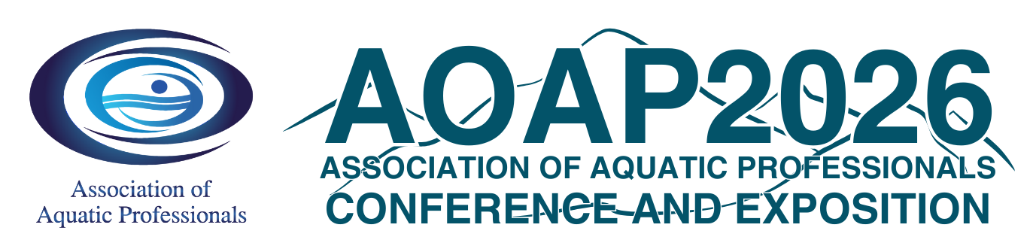

Date:
Dear [Immediate Supervisor Name and Title],
I am writing to request approval to attend the Association of Aquatic Professionals (AOAP) Annual Conference and Exposition taking place February 16 - 19, 2026, in Colorado Springs, Colorado. The AOAP Conference is the foremost aquatics event in the nation. The education, networking, and professional development opportunities offered during the conference are one of a kind. I will be among other professionals to learn about the latest trends, legislation, and issues facing our industry.
The conference delivers content that covers (safety and risk management, management, maintenance and programming). After reviewing the conference information, I have identified a number of educational sessions that will allow me to gain knowledge and understanding about how to improve operations and programming for [name of your organization]. These sessions will be presented by experts and association colleagues who have faced similar challenges and can provide support on important aquatics related issues. Listed below are some of the sessions I plan to attend to strengthen my professional development: [List the sessions you plan to attend as well as the learning outcomes and benefits that will help you, your colleagues, and organization]
The AOAP Exhibit Hall offers me opportunities for networking and business relationship building. Through my involvement I will be able to make professional contacts that will be of assistance to me in the future. The following are some of the exhibitors and professionals from the field I plan to speak with that can help our organization: [List several key vendors, speakers, and/or other professionals with whom you plan to speak]
The cost of registration is $ ( ) and includes all education sessions, the exhibit hall, and most meals. Travel and accommodations are extra.
The AOAP is the premiere association representing aquatic professionals. In the constantly changing aquatics industry, the importance of on-going professional development is paramount to our organization and me. The conference and membership benefits offer me opportunities to enhance my knowledge in order to stay on top of changing trends and laws that affect the aquatics industry. The investment will pay off in more efficient practices, proven solutions, new insights, and ideas. After returning, I will provide a summary of my attendance as well as share resources and information with you and my colleagues.
Thank you for considering my attendance at this important conference.
Sincerely,

[Your Name]

